PROGRAMMABLE AC POWER CONTROL

ABSTRACT

Based on the principle of firing angle control of thyristors, one can control the ac power. A display unit displays the full power or any percentage and one can enter the desired percentage to reduce the power to the load. The firing angle would be automatically adjusted to maintain the load power. The project uses a lamp such that the entered power matches the required one. The above operation is carried out by using a TRIAC in series with the AC load. (optionally two no’s of SCRs connected in back to back can also be used)

It uses microcontroller from PIC family. The input is given to the Microcontroller using a keypad and ZVS is given as reference. A 16X2 LCD is used for display purpose.

The power supply consists of a step down transformer 230/12V, which steps down the voltage to 12V AC. This is converted to DC using a Bridge rectifier. The ripples are removed using a capacitive filter and it is then regulated to +5V using a voltage regulator 7805 which is required for the operation of the microcontroller and other components.

BLOCK DIAGRAM

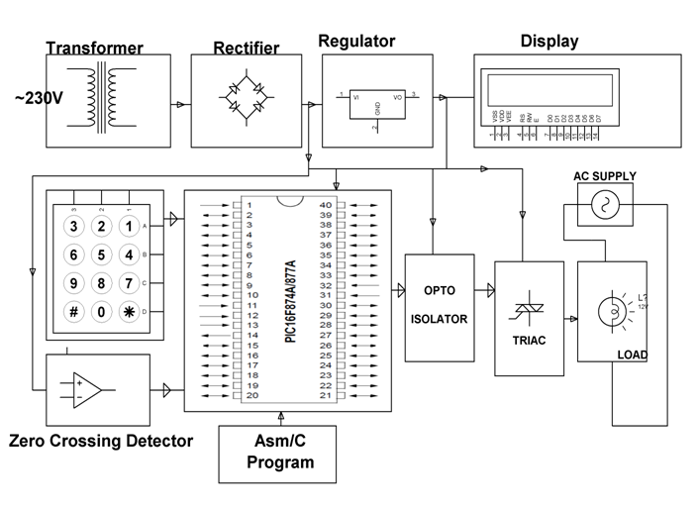

**SOFTWARE REQUIREMENTS:**

MPLAB, HI-TECH PICC Tool suite

Languages: Embedded C Or Assembly

**HARDWARE REQUIREMENTS:**

Microcontroller (PIC16F877A), TRIAC, LCD, Transformer, Regulator, Capacitors, Resistors, Diodes, keypad, Opto Isolator, lamp.